5. Write a C program to find whether the number is palindrome.
#include <stdio.h>
int main(){
int num,original,reversed=0,remainder;
printf("enter a number:");
scanf("%d",num);
original=num;
while(num>0){
remainder=num%10;
remainder=reversed*10+remainder;
num=num/10;
}
if(original=reversed) {
printf("%d is an palindrome number.\n",original); }
else{
printf("%d is NOT an palindrome number.\n”,original);}
return 0;
}
OUTPUT:
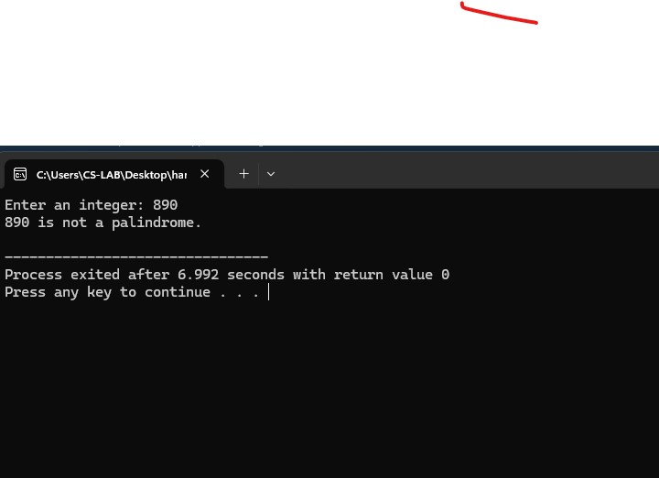
6. Write a C program to find the armstrong number.
#include <stdio.h>
int main() {
int num, originalNum, remainder, result = 0;
printf("Enter a three-digit integer: ");
scanf("%d", &num);
originalNum = num;
while (originalNum != 0) {
remainder = originalNum % 10;
result += remainder * remainder * remainder;
originalNum /= 10;
}
if (result == num) {
printf("%d is an Armstrong number.\n", num);
} else {
printf("%d is not an Armstrong number.\n", num);
}
return 0;
}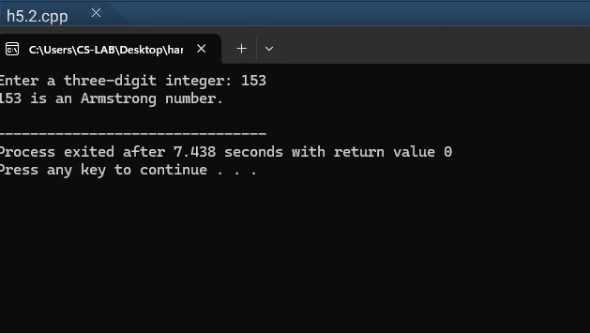
1. Write a C program to search for an element from the list of elements.
#include <stdio.h>
int main() {
int n, search, num, i, found = 0;
printf("Enter the number of elements: ");
scanf("%d", &n);
printf("Enter the element to search: ");
scanf("%d", &search);
for(i = 1; i <= n; i++) {
printf("Enter element %d: ", i);
scanf("%d", &num);
if(num == search) {
found = 1;
printf("Element %d found at position %d.\n", search, i);
break;
}
}
if(!found) {
printf("Element %d not found.\n", search);
}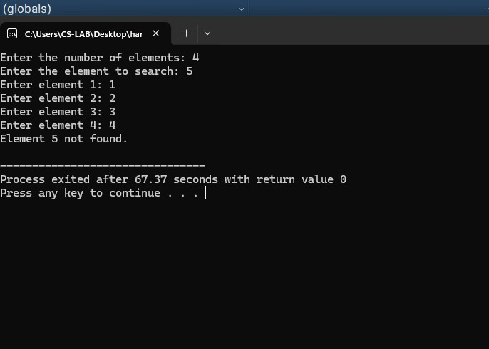
return 0;
2. Write a C program to perform the comparison of two or more integers and display the largest and smallest element.
#include <stdio.h>
int main() {
int n, i, num;
int largest, smallest;
printf("Enter the number of integers to compare: ");
scanf("%d", &n);
if (n <= 0) {
printf("Please enter a positive number of integers.\n");
return 1;}
printf("Enter integer 1: ");
scanf("%d", &num);
largest = num;
smallest = num;
for (i = 2; i <= n; i++) {
printf("Enter integer %d: ", i);
scanf("%d", &num);
if (num > largest) {
largest = num; }
if (num < smallest)
{ smallest = num;
} }
printf("The largest integer is: %d\n", largest); printf("The smallest integer is: %d\n",
smallest);
return 0; }
OUTPUT:

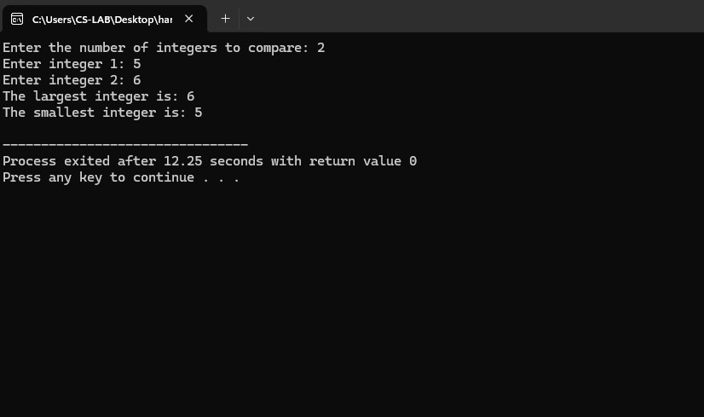

3. Write a program to display the sum of all numbers between 1000 to 2000 which are divisible by 3.
#include <stdio.h>
int main() {
int sum = 0;
for (int i = 1000; i <= 2000; i++) {
if (i % 3 == 0) {
sum += i;
}
}
printf("The sum of all numbers between 1000 and 2000
divisible by 3 is: %d\n", sum);
return 0;
}

OUTPUT:
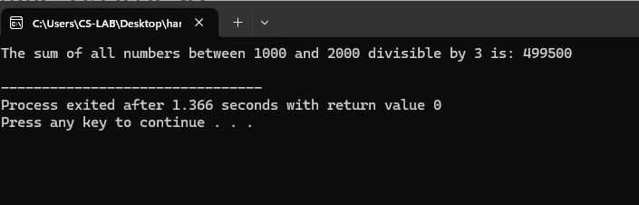
4. Write a C program for menu driven calculator using do-while and switch statements.
#include <stdio.h>
int main() {
int choice;
float num1, num2, result;
do {
printf("\nMenu:\n");
printf("1. Addition\n");
printf("2. Subtraction\n");
printf("3. Multiplication\n");
printf("4. Division\n");
printf("5. Exit\n");
printf("Enter your choice (1-5): ");
scanf("%d", &choice);
choice
switch (choice) {
case 1:
printf("Enter two numbers: ");
scanf("%f %f", &num1, &num2);
result = num1 + num2;
printf("Result: %.2f\n", result);
break;
case 2:
printf("Enter two numbers: ");
scanf("%f %f", &num1, &num2);
result = num1 - num2;
printf("Result: %.2f\n", result);
break;
case 3:
printf("Enter two numbers: ");
scanf("%f %f", &num1, &num2);
result = num1 * num2;
printf("Result: %.2f\n", result);
break;
case 4:
printf("Enter two numbers: ");
scanf("%f %f", &num1, &num2);
if (num2 != 0) {
result = num1 / num2;
printf("Result: %.2f\n", result);
} else {
printf("Error! Division by zero is not
allowed.\n");
}
break;
case 5:
printf("Exiting the program.\n");
break;
default:
printf("Invalid choice! Please enter a number
between 1 and 5.\n");
}
} while (choice != 5);
selects 5 to exit
return 0;
}
OUTPUT:
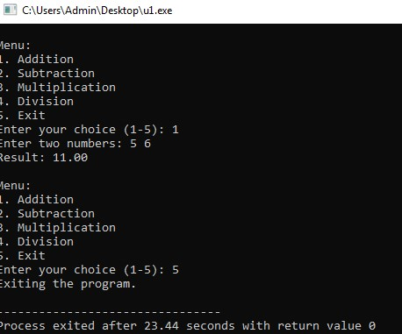

7. Write a C program to generate Arithmetic Progression and Geometric Progression series.
#include <stdio.h>
int main() {
int n, i;
float a, d, r, term;
printf("Enter the first term (a): ");
scanf("%f", &a);
printf("Enter the number of terms (n): ");
scanf("%d", &n);
printf("Enter the common difference for AP (d): ");
scanf("%f", &d);
printf("Enter the common ratio for GP (r): ");
scanf("%f", &r);
printf("\nArithmetic Progression (AP) Series:\n");
term = a;
for (i = 0; i < n; i++) {
printf("%.2f ", term);
term += d;
}
printf("\n\nGeometric Progression (GP) Series:\n");
term = a;
for (i = 0; i < n; i++) {
printf("%.2f ", term);
term *= r;
}
return 0;
}
OUTPUT:
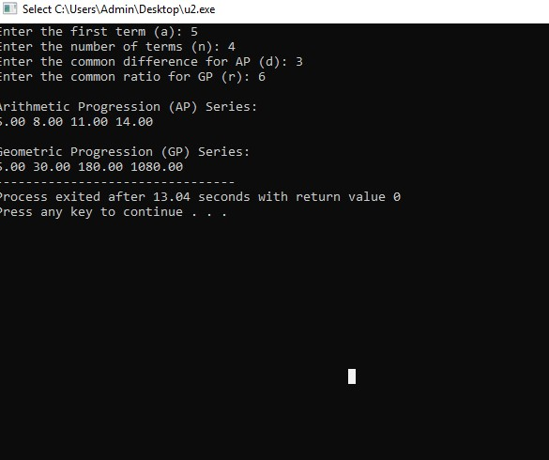

8. Write a C program to print the following patterns and numbers
#include <stdio.h>
int main() {
int n = 5;
for (int i = n; i >= 1; i--) {
for (int j = 1; j <= i; j++) {
printf("*");
}
printf("\n");
}
return 0;
}
OUTPUT:
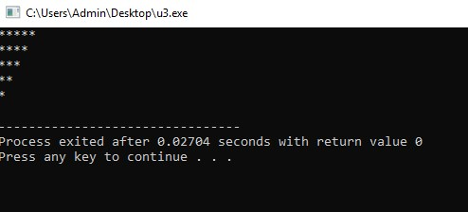

#include<stdio.h>
int main() {
int n = 5, count = 1;
for (int i = 1; i <= n; i++) {
for (int j = 1; j <= i; j++) {
printf("%d ", count);
count++;
}
printf("\n");
}
return 0;
}
OUTPUT:
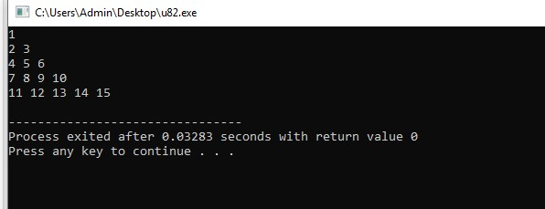

#include <stdio.h>
int main() {
int n = 5;
for (int i = 1; i <= n; i++) {
for (int j = 1; j <= i; j++) {
printf("%d ", j);
}
printf("\n");
}
return 0;
}
OUTPUT:
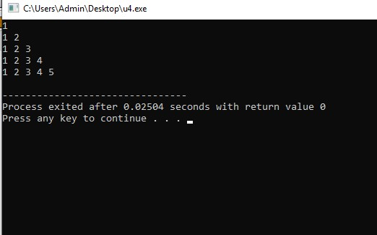

#include <stdio.h>
int main() {
int n = 5;
for (int i = 1; i <= n; i++) {
for (int j = 1; j <= i; j++) {
printf("*");
}
printf("\n");
}
return 0;
}
OUTPUT:
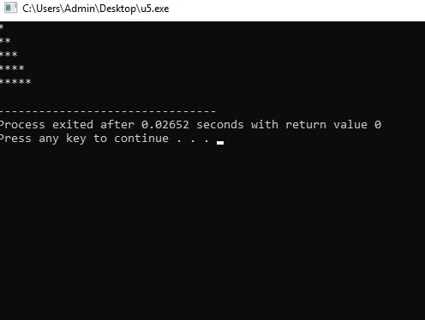

#include <stdio.h>
int main() {
int rows = 5;
int num = 1;
for (int i = 1; i <= rows; i++) {
for (int j = i; j < rows; j++) {
printf(" ");
}
for (int j = 1; j <= i; j++) {
printf("%d ", num);
num++;
}
printf("\n");
}
return 0;
}
